1..PRODUCT SALES ANALYSIS I

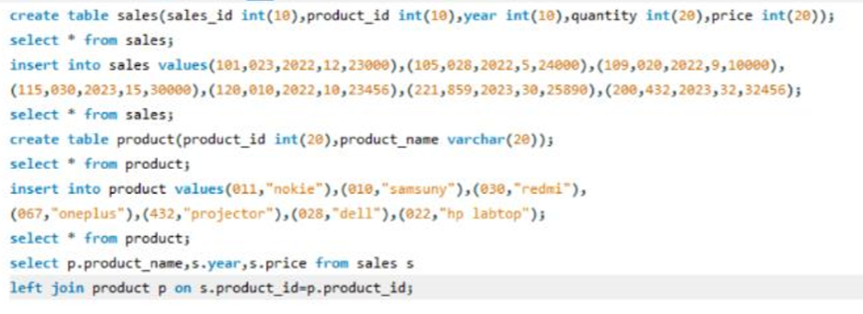

2. .PRODUCT SALES ANALYSIS II

